|  |  |
| --- | --- |
| **NAME** | V.Gokulakrishnan |
| **REG. NO.** | 420121106016 |
| **DEPARTMENT** | ECE |
| **YEAR** | III |
| **COLLEGE NAME** | AKTMCET |
| **GROUP** | IBM GROUP-5 |

### AQM- AIR QUALITY MONITORING

**PHASE-3**

### Innovation

* In this phase you need to put your design into innovation to solve the problem.
* Explain in detail the complete steps that will be taken by you to put your design that you thought of in previous phase into transformation.
* Create a document around it and share the same for assessment.

# Module 6: INTRODUCTION TO PYTHON

Python is a widely used general-purpose, high level programming language. It was created by Guido van Rossum in 1991 and further developed by the Python Software Foundation. It was designed with an emphasis on code readability, and its syntax allows programmers to express their concepts in fewer lines of code.

Python is a programming language that lets you work quickly and integrate systems more efficiently.

**Beginning with Python programming:**

##### Finding an Interpreter:

***Windows*:** There are many interpreters available freely to run Python scripts like IDLE (Integrated Development Environment) that comes bundled with the Python software downloaded from [**http://python.org/**](http://python.org/).

***Linux*:** Python comes preinstalled with popular Linux distros such as Ubuntu and Fedora. To check which version of Python you’re running, type “python” in the terminal emulator. The interpreter should start and print the version number. ***macOS*:** Generally, Python 2.7 comes bundled with macOS.

##### Writing our first program:

Just type in the following code after you start the interpreter.

# Script Begins

print("GeeksQuiz")

# Scripts Ends

Output:

GeeksQuiz

Let’s analyze the script line by line.

***Line 1: [*# Script Begins]** In Python, comments begin with a #. This statement is ignored by the interpreter and serves as documentation for our code.

***Line 2: [print(“GeeksQuiz”)]*** To print something on the console, print() function is used. This function also adds a newline after our message is printed(unlike in C). Note that in Python 2, “print” is not a function but a keyword and therefore can be used without parentheses. However, in Python 3, it is a function and must be invoked with parentheses.

***Line 3: [*# Script Ends]** This is just another comment like in Line 1.

Python designed by Guido van Rossum at CWI has become a widely used general-purpose, high-level programming language.

**Prerequisites:**

Knowledge of any programming language can be a plus.

##### LANGUAGE FEATURES

###### Interpreted

* + There are no separate compilation and execution steps like C and C++.
  + Directly *run* the program from the source code.
  + No need to worry about linking and loading with libraries, etc.

###### Platform Independent

* + Python programs can be developed and executed on multiple operating system platforms.
  + Python can be used on Linux, Windows, Macintosh, Solaris and many more.
* **Free and Open Source;** Redistributable

###### High-level Language

* + In Python, no need to take care about low-level details such as managing the memory used by the program.

###### Simple

* + Closer to English language;Easy to Learn
  + More emphasis on the solution to the problem rather than the syntax

###### Embeddable

* + Python can be used within C/C++ program to give scripting capabilities for the program’s users.

###### Robust:

* + Exceptional handling features
  + Memory management techniques in built

###### Python vs JAVA

|  |  |
| --- | --- |
| **Python** | **Java** |
| **Dynamically Typed**   * No need to declare anything. An assignment statement binds a name to an object, and the object can be of any type. * No type casting is required when | **Statically Typed**   * All variable names (along with their types) must be explicitly declared. Attempting to assign an object of the wrong type to a variable name triggers a type exception. * Type casting is required when using container |

|  |  |
| --- | --- |
| **Python** | **Java** |
| using container objects | objects. |
| **Concise** Express much in limited words | **Verbose** Contains more words |
| **Compact** | **Less Compact** |
| **Uses Indentation for structuring code** | **Uses braces for structuring code** |

The classical **Hello World program** illustrating the **relative verbosity** of a Java Program and Python Program

###### Java Code

public class HelloWorld

{

public static void main (String[] args)

{

System.out.println("Hello, world!");

}

}

**Python Code**

print("Hello, world!")

###### Similarity with Java

* Require some form of runtime on your system (JVM/Python runtime)
* Can probably be compiled to executables without the runtime (this is situational, none of them are designed to work this way)

###### LOOK and FEEL of the Python

**GUI**

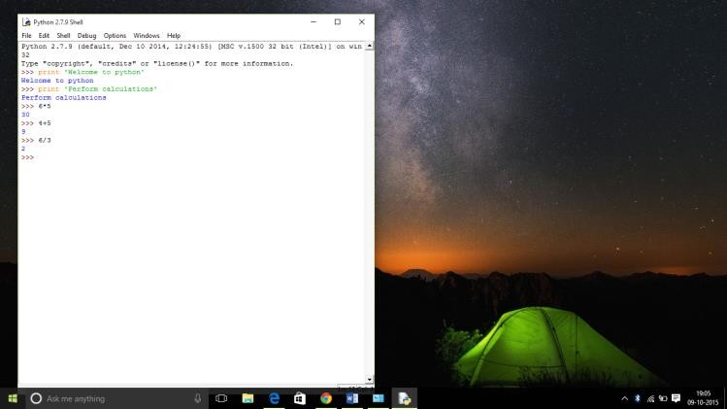

###### Command Line interface

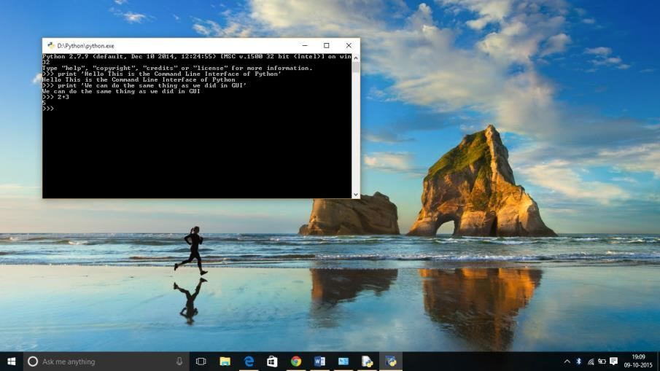

**Softwares making use of Python**

Python has been successfully embedded in a number of software products as a scripting language.

1. GNU Debugger uses Python as a **pretty printer** to show complex structures such as C++ containers.
2. Python has also been used in artificial intelligence
3. Python is often used for **natural language processing** tasks.

###### Current Applications of Python

1. A number of Linux distributions use installers written in Python example in Ubuntu we have the **Ubiquity**
2. Python has seen extensive use in the **information security industry**, including in exploit development.
3. Raspberry Pi– single board computer uses Python as its principal user- programming language.
4. Python is now being used **Game Development** areas also.

###### Pros:

1. Ease of use
2. Multi-paradigm Approach

###### Cons:

1. Slow speed of execution compared to C,C++
2. Absence from mobile computing and browsers

##### Advantages :

1. Presence of third-party modules
2. Extensive support libraries(NumPy for numerical calculations, Pandas for data analytics etc)
3. Open source and community development
4. Versatile, Easy to read, learn and write
5. User-friendly data structures
6. High-level language
7. Dynamically typed language(No need to mention data type based on the value assigned, it takes data type)
8. Object-oriented language
9. Portable and Interactive
10. Ideal for prototypes – provide more functionality with less coding

##### Applications :

1. GUI based desktop applications
2. Graphic design, image processing applications, Games, and Scientific/ computational Applications
3. Web frameworks and applications
4. Enterprise and Business applications
5. Operating Systems
6. Education
7. Database Access
8. Language Development
9. Prototyping
10. Software Development

##### Organizations using Python :

1. Google(Components of Google spider and Search Engine)
2. Yahoo(Maps)
3. YouTube
4. Mozilla
5. Dropbox
6. Microsoft
7. Cisco
8. Spotify
9. Quora

# Module 7: RASPBERRY PI

* The first-generation **Raspberry Pi Model B** was released in February 2012, followed by the simpler and cheaper **Model A**.
* In 2014, the Raspberry Pi Foundation released a board with an improved design, **Raspberry Pi Model B+**. These first-generation boards feature [ARM11 processors](https://en.wikipedia.org/wiki/ARM11), are approximately credit- card sized, and represent the standard *mainline* form factor. Improved A+ and B models were released within a year. A ["Compute Module"](https://en.wikipedia.org/wiki/Raspberry_Pi#Compute_module) was released in April 2014 for [embedded](https://en.wikipedia.org/wiki/Embedded_system) [applications.](https://en.wikipedia.org/wiki/Embedded_system)

#### Raspberry Pi Zero

* A **Raspberry Pi Zero** with smaller size and reduced [input/output](https://en.wikipedia.org/wiki/Input/output) (I/O) and [general-purpose](https://en.wikipedia.org/wiki/General-purpose_input/output) [input/output](https://en.wikipedia.org/wiki/General-purpose_input/output) (GPIO) capabilities was released in November 2015 for $5 USD.
* On May 16, 2016, the **Raspberry Pi Zero v1.3** was released, which added a camera connector[.[27]](https://en.wikipedia.org/wiki/Raspberry_Pi#cite_note-27)
* On February 28, 2017, the **Raspberry Pi Zero W** was launched, a version of the Zero with Wi-Fi and Bluetooth capabilities, for $10 USD.[[28][29]](https://en.wikipedia.org/wiki/Raspberry_Pi#cite_note-28)
* On January 12, 2018, the **Raspberry Pi Zero WH** was launched, a version of the Zero W with pre-soldered GPIO headers.[[30]](https://en.wikipedia.org/wiki/Raspberry_Pi#cite_note-30)
* On October 28, 2021, the **Raspberry Pi Zero 2 W** was launched, a version of the Zero W with a [system in a package](https://en.wikipedia.org/wiki/System_in_a_package) (SiP) designed by Raspberry Pi and based on the Raspberry Pi 3.[[31]](https://en.wikipedia.org/wiki/Raspberry_Pi#cite_note-PiZero2WAnnouncement-31) In contrast to the older Zero models, the Pi Zero 2 W is 64-bit capable. The price is around $15 in USD.

Hardware

The Raspberry Pi hardware has evolved through several versions that feature variations in the type of the central processing unit, amount of [memory](https://en.wikipedia.org/wiki/Computer_memory) capacity, networking support, and peripheral- device support.

Processor speed ranges from 700 MHz to 1.4 GHz for the Pi 3 Model B+ or 1.5 GHz for the Pi 4; on- board memory ranges from 256 [MB](https://en.wikipedia.org/wiki/Megabyte) to 8 [GB](https://en.wikipedia.org/wiki/Gigabyte) [random-access memory](https://en.wikipedia.org/wiki/Random-access_memory) (RAM), with only the Raspberry Pi 4 having more than 1 GB.

#### Processor

The Broadcom BCM2835 SoC used in the first generation Raspberry Pi[[47]](https://en.wikipedia.org/wiki/Raspberry_Pi#cite_note-Broadcom-BCM2835-Website-56) includes a 700 [MHz](https://en.wikipedia.org/wiki/Hertz) [32-](https://en.wikipedia.org/wiki/32-bit) [bit](https://en.wikipedia.org/wiki/32-bit) [ARM11](https://en.wikipedia.org/wiki/ARM11)76JZF-S processor, [VideoCore](https://en.wikipedia.org/wiki/VideoCore) IV [graphics processing unit](https://en.wikipedia.org/wiki/Graphics_processing_unit) (GPU)[,[48]](https://en.wikipedia.org/wiki/Raspberry_Pi#cite_note-grandmax_brose_2012-57) and RAMThe Raspberry Pi 5 uses the Broadcom BCM2712 SoC, which is a chip designed in collaboration with Raspberry Pi.

The SoC features a quad-core [ARM Cortex-A76](https://en.wikipedia.org/wiki/ARM_Cortex-A76) processor clocked at 2.4 GHz, alongside a VideoCore VII GPU clocked at 800 MHz. The BCM2712 SoC also features support for [cryptographic](https://en.wikipedia.org/wiki/Cryptography) [extensions](https://en.wikipedia.org/wiki/Cryptography) for the first time on a Raspberry Pi model

**Performance**[[edit](https://en.wikipedia.org/w/index.php?title=Raspberry_Pi&action=edit&section=8)]

While operating at 700 MHz by default, the first generation Raspberry Pi provided a real-world performance roughly equivalent to 0.041 [GFLOPS](https://en.wikipedia.org/wiki/FLOPS)[.[64][65]](https://en.wikipedia.org/wiki/Raspberry_Pi#cite_note-eLinux-perf-73) On the CPU level the performance is similar to a 300 MHz [Pentium II](https://en.wikipedia.org/wiki/Pentium_II) of 1997–99.

The Raspberry Pi 4, with a quad-core [Cortex-A72](https://en.wikipedia.org/wiki/ARM_Cortex-A72) processor, is described as having three times the performance of a Raspberry Pi 3.[[17]](https://en.wikipedia.org/wiki/Raspberry_Pi#cite_note-Pi4OnSale-17)

**Overclocking**[[edit](https://en.wikipedia.org/w/index.php?title=Raspberry_Pi&action=edit&section=9)]

Most Raspberry Pi [systems-on-chip](https://en.wikipedia.org/wiki/System_on_a_chip) can be [overclocked](https://en.wikipedia.org/wiki/Overclocking) to various degrees utilising the built in config.

In [Raspberry Pi OS](https://en.wikipedia.org/wiki/Raspberry_Pi_OS) the overclocking options on [boot](https://en.wikipedia.org/wiki/Booting) can also be made by a software command running "sudo raspi-config" on Raspberry Pi 1, 2, and original 3B without voiding the warranty.

The overclocking modes are:

|  |  |  |  |  |
| --- | --- | --- | --- | --- |
| **none** | 700 MHz ARM | 250 MHz  core | 400 MHz SDRAM | 0 [overvolting](https://en.wikipedia.org/wiki/Overvolting) |
| **modest** | 800 MHz ARM | 250 MHz  core | 400 MHz SDRAM | 0 overvolting |
| **medium** | 900 MHz ARM | 250 MHz  core | 450 MHz SDRAM | 2 overvolting |
| **high** | 950 MHz ARM | 250 MHz  core | 450 MHz SDRAM | 6 overvolting |
| **turbo** | 1000 MHz ARM | 500 MHz  core | 600 MHz SDRAM | 6 overvolting |
| **Pi 2** | 1000 MHz ARM | 500 MHz  core | 500 MHz SDRAM | 2 overvolting |
| **Pi 3** | 1100 MHz ARM | 550 MHz  core | 500 MHz SDRAM | 6 overvolting.  In system information the CPU speed appears as 1200 MHz. When idling, speed lowers to |

|  |  |  |  |  |
| --- | --- | --- | --- | --- |
|  |  |  |  | 600 MHz.[[70][71]](https://en.wikipedia.org/wiki/Raspberry_Pi#cite_note-Turbo_mode-79) |

#### RAM

The early designs of the Raspberry Pi Model A and B boards included only 256 MB of [random](https://en.wikipedia.org/wiki/Random_access_memory) [access memory](https://en.wikipedia.org/wiki/Random_access_memory) (RAM).

The Raspberry Pi 3 has 1 GB of RAM in the B and B+ models, and 512 MB of RAM in the A+ model[.[77][78](https://en.wikipedia.org/wiki/Raspberry_Pi#cite_note-86)[][79]](https://en.wikipedia.org/wiki/Raspberry_Pi#cite_note-88) The Raspberry Pi Zero and Zero W have 512 MB of RAM.

The Raspberry Pi 4 is available with 1, 2, 4 or 8 GB of RAM[.[80]](https://en.wikipedia.org/wiki/Raspberry_Pi#cite_note-89) A 1 GB model was originally available at launch in June 2019 but was discontinued in March 2020,[[40]](https://en.wikipedia.org/wiki/Raspberry_Pi#cite_note-TwoGBMin-47) and the 8 GB model was introduced in May 2020.[[81]](https://en.wikipedia.org/wiki/Raspberry_Pi#cite_note-EightGB-90) The 1 GB model returned in October 2021.[[82]](https://en.wikipedia.org/wiki/Raspberry_Pi#cite_note-1GBReturns-91)

#### Networking

The Model A, A+ and Pi Zero have no Ethernet circuitry and are commonly connected to a network using an external user-supplied USB Ethernet or [Wi-Fi](https://en.wikipedia.org/wiki/Wi-Fi) adapter. On the Model B and B+ the Ethernet port is provided by a built-in USB Ethernet adapter using the SMSC LAN9514 chip

#### Special-purpose features

The RPi Zero, RPi1A, RPi3A+[[85]](https://en.wikipedia.org/wiki/Raspberry_Pi#cite_note-94) and RPi4 can be used as a USB device or "USB gadget", plugged into another computer via a USB port on another machine. It can be configured in multiple ways, such as functioning as a [serial](https://en.wikipedia.org/wiki/Serial_port) or Ethernet device.[[86]](https://en.wikipedia.org/wiki/Raspberry_Pi#cite_note-adafruitgadget-95) Although originally requiring software patches, this was added into the mainline Raspbian distribution in May 2016.[[86]](https://en.wikipedia.org/wiki/Raspberry_Pi#cite_note-adafruitgadget-95)

#### Peripherals

Although often pre-configured to operate as a [headless computer](https://en.wikipedia.org/wiki/Headless_computer), the Raspberry Pi may also optionally be operated with any generic [USB computer keyboard](https://en.wikipedia.org/wiki/USB_computer_keyboard) and [mouse.](https://en.wikipedia.org/wiki/Computer_mouse)

Other peripherals can be attached through the various pins and connectors on the surface of the Raspberry Pi[.[89]](https://en.wikipedia.org/wiki/Raspberry_Pi#cite_note-98)

#### Video

An early Raspberry Pi 1 Model A, with an HDMI port and a standard RCA composite video port for older displays

The video controller can generate standard modern TV resolutions, such as HD and [Full HD](https://en.wikipedia.org/wiki/Full_HD), and higher or lower monitor resolutions as well as older NTSC or PAL standard [CRT](https://en.wikipedia.org/wiki/Cathode-ray_tube) TV resolutions. As shipped (i.e., without custom overclocking.

The Raspberry Pis can also generate [576i](https://en.wikipedia.org/wiki/576i) and [480i](https://en.wikipedia.org/wiki/480i) [composite video](https://en.wikipedia.org/wiki/Composite_video) signals, as used on old-style (CRT) TV screens and less-expensive monitors through standard connectors – either RCA or

* 1. mm phono connector depending on model

#### Real-time clock

When booting, the time defaults to being set over the network using the [Network Time](https://en.wikipedia.org/wiki/Network_Time_Protocol) [Protocol](https://en.wikipedia.org/wiki/Network_Time_Protocol) (NTP). The source of time information can be another computer on the local network that *does* have a real-time clock, or to a [NTP server](https://en.wikipedia.org/wiki/NTP_server) on the internet

The RP2040 microcontroller has a built-in [real-time clock](https://en.wikipedia.org/wiki/Real-time_clock) but this can not be set automatically without some form of user entry or network facility being added.

# Module 8: INTRODUCTION TO CLOUD

Introduction to Cloud Computing

**Cloud Computing is the delivery of computing services such as servers, storage, databases, networking, software, analytics, intelligence, and more, over the Cloud (Internet).**

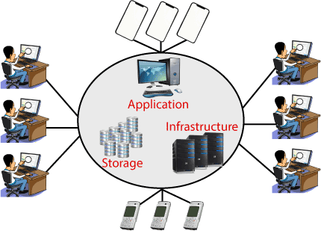

Cloud Computing provides an alternative to the on-premises datacentre. With an on- premises datacentre, we have to manage everything, such as purchasing and installing hardware, virtualization, installing the operating system, and any other required applications, setting up the network, configuring the firewall, and setting up storage for data. We can take any required services on rent. The cloud computing services will be charged based on usage.

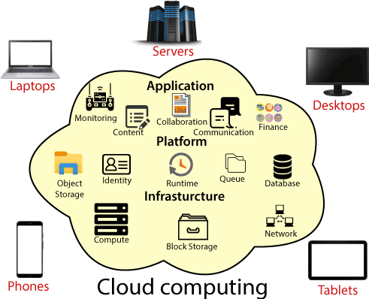

The cloud environment provides an easily accessible online portal that makes handy for the user to manage the compute, storage, network, and application resources. Some cloud service providers are in the following figure.

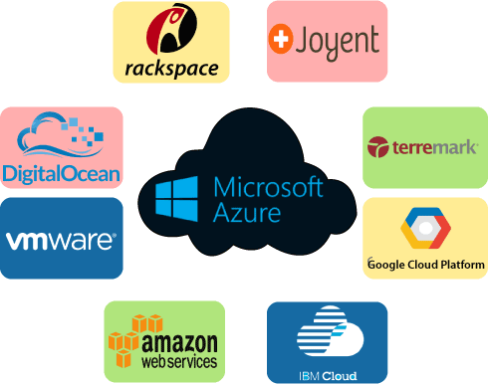

Advantages of cloud computing

* **Cost:** It reduces the huge capital costs of buying hardware and software.
* **Speed:** Resources can be accessed in minutes, typically within a few clicks.
* **Scalability:** We can increase or decrease the requirement of resources according to the business requirements.
* **Productivity:** While using cloud computing, we put less operational effort. We do not need to apply patching, as well as no need to maintain hardware and software.
* **Reliability:** Backup and recovery of data are less expensive and very fast for business continuity.
* **Security:** Many cloud vendors offer a broad set of policies, technologies, and controls that strengthen our data security.

## introduction-to-cloud-computing-3.pngTypes of Cloud Computing

* **Public Cloud:** The cloud resources that are owned and operated by a third-party cloud service provider are termed as public clouds. It delivers computing resources such as servers, software, and storage over the internet
* **Private Cloud:** The cloud computing resources that are exclusively used inside a single business or organization are termed as a private cloud.
* **Hybrid Cloud:** It is the combination of public and private clouds, which is bounded together by technology that allows data applications to be shared between them. Hybrid cloud provides flexibility and more deployment options to the business.

## Types of Cloud Services

* + 1. **Infrastructure as a Service (IaaS):** In IaaS, we can rent IT infrastructures like servers and virtual machines (VMs), storage, networks, operating systems from a cloud service vendor.
    2. **Software as a Service (SaaS):** It provides a centrally hosted and managed software services to the end-users. It delivers software over the internet, on- demand, and typically on a subscription basis. E.g., Microsoft One Drive, Dropbox, WordPress, Office 365, and Amazon Kindle. SaaS is used to minimize the operational cost to the maximum extent.